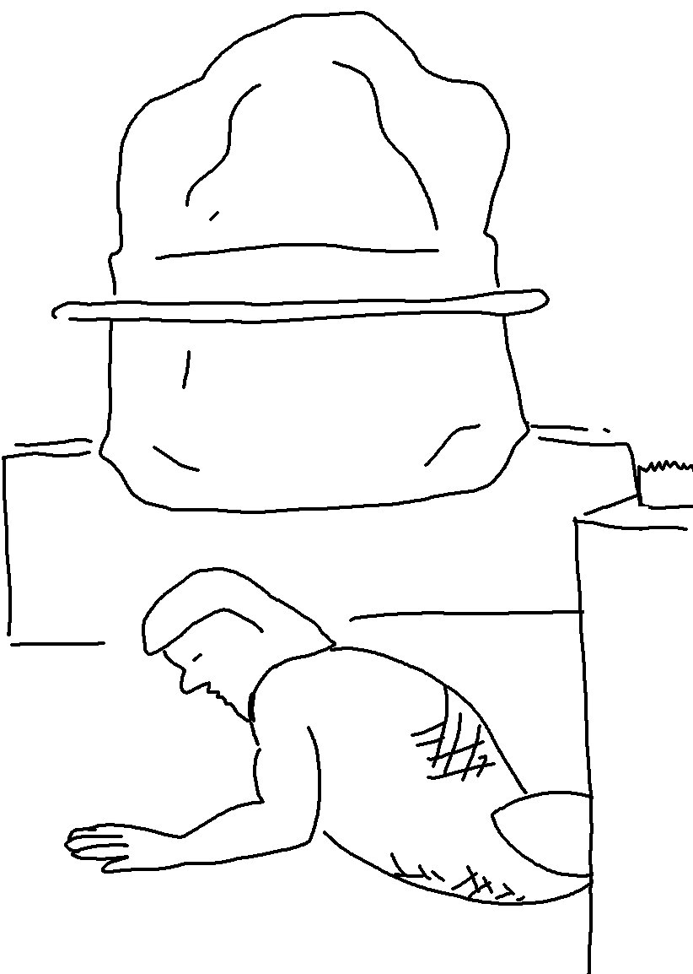

I am the Lord… I will not… share my praise with carved idols. Isaiah 42:8_{NLT}

